**CUSTOMER CARE REGISTRY**



**ABSTRACT**

**INTRODUCTION**

### TEAM DETAILS:



**Team No :** PNT2022TMID26814

**College Name :** Dhanalakshmi Srinivasan College of Engineering & Technology

**Department :** Computer Science & Engineering

### PROBLEM STATEMENT :

A problem statement is a concise description of the problem or issues a project seeks to address. The problem statement identifies the current state, the desired future state and any gaps between the two. A problem statement is an important communication tool that can help ensure everyone working on a project knows what the problem they need to address is and why the project is important.

Problem Statement 3

# CUSTOMER:

## PROBLEM STATEMENTS

Customer

Needs a way to

Register their

Account

So that

They can Login and Raise their Issue

Customer

Will

Raise the Ticket

thus

Issue will be

Resolved

Customer

Will able to

Track the issue

In which

Status can be seen in Email

Problem Statement 4

AGENT

## PROBLEM STATEMENTS

Agent

Can

View the

complaints

So that

Will Follow through email

Agent

can

Track the work assigned to the agent

Make sure that

Customer Ticket will be resolved

Problem Statement 5

**PROBLEM STATEMENTS**

# AGENT :

Admin

Can

Track the work assigned to the agent

Make sure that

Customer ticket will be resolved

Problem Statement 6

## PROBLEM DEFINITIONS

Customer wants to fix a blue screen of death?

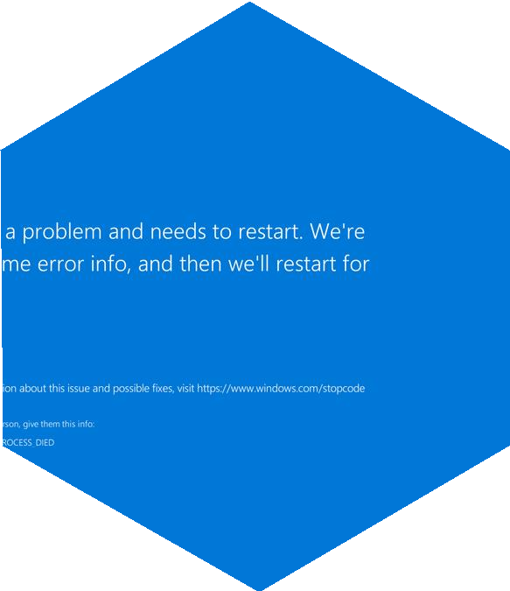

|  |  |
| --- | --- |
| **QUESTION** | **DESCRIPTIONS** |
| Who does the Problem Affect? | Customer who use the particular thing |
| What are the boundaries of the problem? | Customer who use the thing for their personal  work, office work etc |
| What is the issue? | Failure of Hardware or driver sometimes it may be in software too |
| When does the issue occur? | It frequently occurs after the customer installed new drivers or new piece of software |
| Where does the issue occur? | It often lies in the Hardware or one of the  drivers |
| Why is it important that we fix the problem? | It is necessary to run the computer or Laptop to do their task or work in order to complete it. |
| What solution to solve this issue? | A quick reboot is sometimes enough to solve the problem |
| What methodology used to solve the issue? | By means of troubleshoot the process or  resetting of the software and hardware |

Problem Definitions 7

## PROBLEM DEFINITION

Customer wants to fix the Payment issue?



|  |  |
| --- | --- |
| **QUESTION** | **DESCRIPTIONS** |
| Who does the Problem Affect? | Customer who use the particular thing |
| What is the solution to solve this issue temporarily? | Check payment method is up to date or Try another payment method |
| How the issue occurs? | Customer who has entered incorrect card information, payment gateway, or the bank institution issue |
| When does the issue occur? | It occurs when there is insufficient balance in bank account |
| Why is it important that we fix the problem? | For the welfare of the customer needs |

Problem Definition 8

**Thank you**